- Keras Sequential Model
The Sequential model API is a way of creating deep learning models where an instance of the Sequential class is created and model layers are created and added to it.
model = Sequential()
model.add(Dense(2, input_dim=1))
model.add(Dense(1))

- Keras Functional Model
It specifically allows you to define multiple input or output models as well as models that share layers. More than that, it allows you to define ad hoc acyclic network graphs.
- Input: The input layer takes a shape argument that is a tuple that indicates the dimensionality of the input data. The shape tuple is always defined with a hanging last dimensión, for batch size
- Hidden: These layers are interconnected to each other
- Model: Use Input and hidden layers
visible = Input(shape=(2,))
hidden = Dense(2)(visible)
model = Model(inputs=visible, outputs=hidden)

- Multilayer Perceptron
The model has 10 inputs, 3 hidden layers with 10, 20, and 10 neurons, and an output layer with 1 output. Rectified linear activation functions are used in each hidden layer and a sigmoid activation function is used in the output layer, for binary classification.

from keras.utils import plot_model
from keras.models import Model
from keras.layers import Input
from keras.layers import Dense
visible = Input(shape=(10,))
hidden1 = Dense(10, activation='relu')(visible)
hidden2 = Dense(20, activation='relu')(hidden1)
hidden3 = Dense(10, activation='relu')(hidden2)
output = Dense(1, activation='sigmoid')(hidden3)
model = Model(inputs=visible, outputs=output)

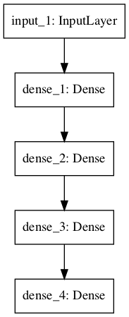

- Convolutional Neural Network
The model receives black and white 64×64 images as input, then has a sequence of two convolutional and pooling layers as feature extractors, followed by a fully connected layer to interpret the features and an output layer with a sigmoid activation for two-class predictions.
from keras.utils import plot_model
from keras.models import Model
from keras.layers import Input
from keras.layers import Dense
from keras.layers import Flatten
from keras.layers.convolutional import Conv2D
from keras.layers.pooling import MaxPooling2D
visible = Input(shape=(64,64,1))
conv1 = Conv2D(32, kernel_size=4, activation='relu')(visible)
pool1 = MaxPooling2D(pool_size=(2, 2))(conv1)
conv2 = Conv2D(16, kernel_size=4, activation='relu')(pool1)
pool2 = MaxPooling2D(pool_size=(2, 2))(conv2)
flat = Flatten()(pool2)
hidden1 = Dense(10, activation='relu')(flat)
output = Dense(1, activation='sigmoid')(hidden1)
model = Model(inputs=visible, outputs=output)

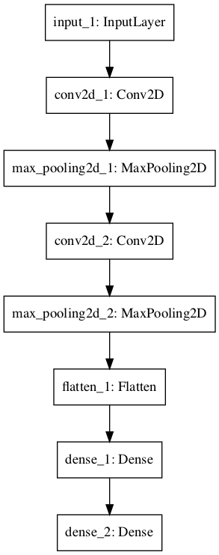

- Recurrent Neural Network
The model expects 100 time steps of one feature as input. The model has a single LSTM hidden layer to extract features from the sequence, followed by a fully connected layer to interpret the LSTM output, followed by an output layer for making binary predictions.
from keras.utils import plot_model
from keras.models import Model
from keras.layers import Input
from keras.layers import Dense
from keras.layers.recurrent import LSTM
visible = Input(shape=(100,1))
hidden1 = LSTM(10)(visible)
hidden2 = Dense(10, activation='relu')(hidden1)
output = Dense(1, activation='sigmoid')(hidden2)
model = Model(inputs=visible, outputs=output)

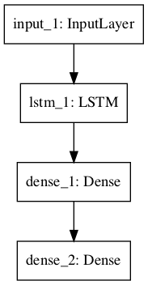

- Shared layers model
A couple of examples
- Shared input layer:
The model takes black and white images with the size 64×64 pixels. There are two CNN feature extraction submodels that share this input; the first has a kernel size of 4 and the second a kernel size of 8. The outputs from these feature extraction submodels are flattened into vectors and concatenated into one long vector and passed on to a fully connected layer for interpretation before a final output layer makes a binary classification
from keras.utils import plot_model
from keras.models import Model
from keras.layers import Input
from keras.layers import Dense
from keras.layers import Flatten
from keras.layers.convolutional import Conv2D
from keras.layers.pooling import MaxPooling2D
from keras.layers.merge import concatenate
# input layer
visible = Input(shape=(64,64,1))
# first feature extractor
conv1 = Conv2D(32, kernel_size=4, activation='relu')(visible)
pool1 = MaxPooling2D(pool_size=(2, 2))(conv1)
flat1 = Flatten()(pool1)
# second feature extractor
conv2 = Conv2D(16, kernel_size=8, activation='relu')(visible)
pool2 = MaxPooling2D(pool_size=(2, 2))(conv2)
flat2 = Flatten()(pool2)
# merge feature extractors
merge = concatenate([flat1, flat2])
# interpretation layer
hidden1 = Dense(10, activation='relu')(merge)
# prediction output
output = Dense(1, activation='sigmoid')(hidden1)
model = Model(inputs=visible, outputs=output)
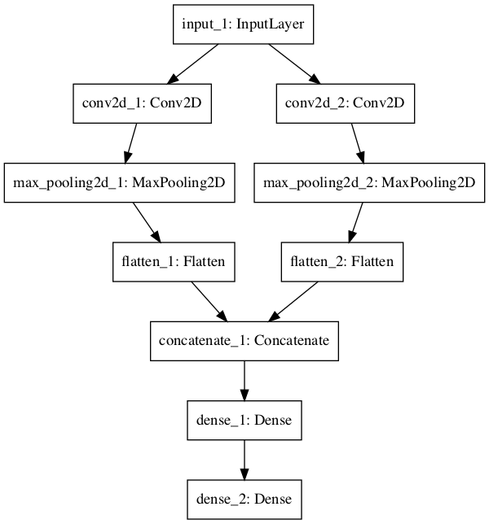

- Shared Feature extraction layer:
The input to the model is 100 time steps of 1 feature. An LSTM layer with 10 memory cells interprets this sequence. The first interpretation model is a shallow single fully connected layer, the second is a deep 3 layer model. The output of both interpretation models are concatenated into one long vector that is passed to the output layer used to make a binary prediction.

from keras.utils import plot_model
from keras.models import Model
from keras.layers import Input
from keras.layers import Dense
from keras.layers.recurrent import LSTM
from keras.layers.merge import concatenate
# define input
visible = Input(shape=(100,1))
# feature extraction
extract1 = LSTM(10)(visible)
# first interpretation model
interp1 = Dense(10, activation='relu')(extract1)
# second interpretation model
interp11 = Dense(10, activation='relu')(extract1)
interp12 = Dense(20, activation='relu')(interp11)
interp13 = Dense(10, activation='relu')(interp12)
# merge interpretation
merge = concatenate([interp1, interp13])
# output
output = Dense(1, activation='sigmoid')(merge)
model = Model(inputs=visible, outputs=output)

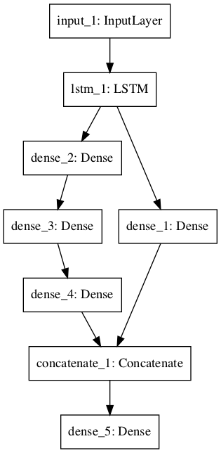
- Multiple input/output model

A couple of these cases:

- Multiple input model:
We will develop an image classification model that takes two versions of the image as input, each of a different size. Specifically a black and white 64×64 version and a color 32×32 version. Separate feature extraction CNN models operate on each, then the results from both models are concatenated for interpretation and ultimate prediction.

from keras.utils import plot_model
from keras.models import Model
from keras.layers import Input
from keras.layers import Dense
from keras.layers import Flatten
from keras.layers.convolutional import Conv2D
from keras.layers.pooling import MaxPooling2D
from keras.layers.merge import concatenate
# first input model
visible1 = Input(shape=(64,64,1))
conv11 = Conv2D(32, kernel_size=4, activation='relu')(visible1)
pool11 = MaxPooling2D(pool_size=(2, 2))(conv11)
conv12 = Conv2D(16, kernel_size=4, activation='relu')(pool11)
pool12 = MaxPooling2D(pool_size=(2, 2))(conv12)
flat1 = Flatten()(pool12)
# second input model
visible2 = Input(shape=(32,32,3))
conv21 = Conv2D(32, kernel_size=4, activation='relu')(visible2)
pool21 = MaxPooling2D(pool_size=(2, 2))(conv21)
conv22 = Conv2D(16, kernel_size=4, activation='relu')(pool21)
pool22 = MaxPooling2D(pool_size=(2, 2))(conv22)
flat2 = Flatten()(pool22)
# merge input models
merge = concatenate([flat1, flat2])
# interpretation model
hidden1 = Dense(10, activation='relu')(merge)
hidden2 = Dense(10, activation='relu')(hidden1)
output = Dense(1, activation='sigmoid')(hidden2)
model = Model(inputs=[visible1, visible2], outputs=output)

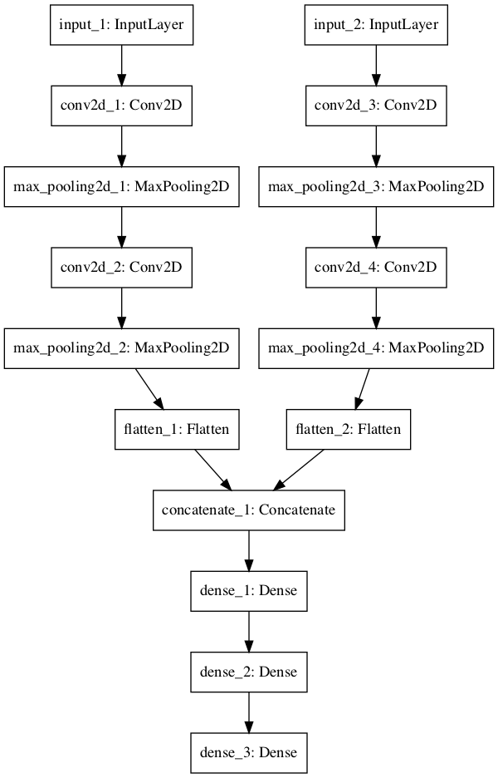
- Multiple output model:
An LSTM layer interprets the input sequence and returns the hidden state for each time step. The first output model creates a stacked LSTM, interprets the features, and makes a binary prediction. The second output model uses the same output layer to make a real-valued prediction for each input time step.

from keras.utils import plot_model
from keras.models import Model
from keras.layers import Input
from keras.layers import Dense
from keras.layers.recurrent import LSTM
from keras.layers.wrappers import TimeDistributed
# input layer
visible = Input(shape=(100,1))
# feature extraction
extract = LSTM(10, return_sequences=True)(visible)
# classification output
class11 = LSTM(10)(extract)
class12 = Dense(10, activation='relu')(class11)
output1 = Dense(1, activation='sigmoid')(class12)
# sequence output
output2 = TimeDistributed(Dense(1, activation='linear'))(extract)
# output
model = Model(inputs=visible, outputs=[output1, output2])

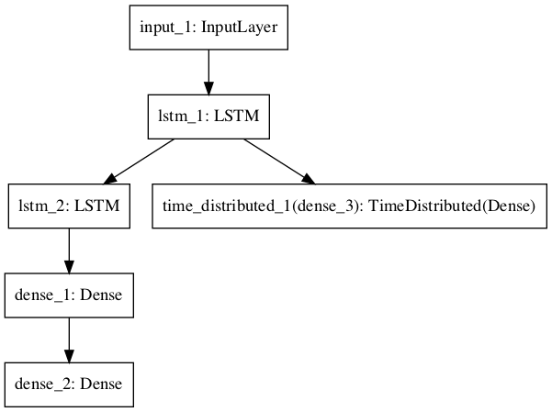

- LSTM (Time Series)
- GANs
- Convolutional Layers
- Filters
The filters are the “neurons” of the layer. The have input weights and output a value. The input size is a fixed square called a patch or a receptive field. If the convolutional layer is an input layer, then the input patch will be pixel values. If the deeper in the network architecture, then the convolutional layer will take input from a feature map from the previous layer. Filters are the feature detectors. Generally fewer filters are used at the input layer and increasingly more filters used at deeper layers.

Feature Maps
The feature map is the output of one filter applied to the previous layer.
A given filter is drawn across the entire previous layer, moved one pixel at a time. Each position results in an activation of the neuron and the output is collected in the feature map

Zero Padding
The distance that filter is moved across the the input from the previous layer each activation is referred to as the stride. Use the default stride of 1. It is easy to understand and you don’t need padding to handle the receptive field falling off the edge of your images

- Fully Connected Layers (CNN)
Fully connected layers are used at the end of the network after feature extraction and consolidation has been performed by the convolutional and pooling layers. They are used to create final non-linear combinations of features and for making predictions by the network.
- Autoencoders
An autoencoder is a neural network model that seeks to learn a compressed representation of an input. They are an unsupervised learning method, although technically, they are trained using supervised learning methods. The more common use is as a learned or automatic feature extraction model.

- Pooling
A pooling layer is a new layer added after the convolutional layer. Specifically, after a nonlinearity (e.g. ReLU) has been applied to the feature maps output by a convolutional layer; for example the layers in a model may look as follows:
Input Image
Convolutional Layer
Nonlinearity
Pooling Layer

Pooling involves selecting a pooling operation, much like a filter to be applied to feature maps. The size of the pooling operation or filter is smaller than the size of the feature map; specifically, it is almost always 2×2 pixels applied with a stride of 2 pixels. This means that the pooling layer will always reduce the size of each feature map by a factor of 2, e.g. each dimension is halved, reducing the number of pixels or values in each feature map to one quarter the size

The pooling operation is specified, rather than learned. Two common functions used in the pooling operation are:
- Average Pooling: Calculate the average value for each patch on the feature map.

pool = AveragePooling2D(pool_size=(2, 2))(conv)

- Maximum Pooling (or Max Pooling): Calculate the maximum value for each patch of the feature map.

pool = MaxPooling2D(pool_size=(2, 2))(conv)

- Activation
Funcion de activación: puede ser “relu”, “softmax”…
- Flatten
Se usa con imágenes, para convertir un array multidimensional en uno de una dimension
- Dense
Layer which is fully interconnected (all neurons) with other layers

- Weight Regularization
There are multiple types of weight regularization, such as L1 and L2 vector norms, and each requires a hyperparameter that must be configured.
from keras.regularizers import l2
model.add(Dense(32, kernel_regularizer=l2(0.01), bias_regularizer=l2(0.01)))

- Weight Constraints
The constraints are specified per-layer, but applied and enforced per-node within the layer. Using a constraint generally involves setting the kernel_constraint argument on the layer for the input weights and the bias_constraint for the bias weights. Generally, weight constraints are not used on the bias weights.
- Maximum norm (max_norm), to force weights to have a magnitude at or below a given limit.
- Non-negative norm (non_neg), to force weights to have a positive magnitude.
- Unit norm (unit_norm), to force weights to have a magnitude of 1.0.
- Min-Max norm (min_max_norm), to force weights to have a magnitude between a range
It is applied on layer Dense (MLP), Conv2D, LSTM,
from keras.constraints import max_norm
model.add(Dense(32, kernel_constraint=max_norm(3), bias_constraint=max_norm(3)))

- Dropout
Dropout is a technique where randomly selected neurons are ignored during training. They are “dropped-out” randomly. This means that their contribution to the activation of downstream neurons is temporally removed on the forward pass and any weight updates are not applied to the neuron on the backward pass.
Dropout is easily implemented by randomly selecting nodes to be dropped-out with a given probability (e.g. 20%) each weight update cycle.
- Generally, use a small dropout value of 20%-50% of neurons with 20% providing a good starting point. A probability too low has minimal effect and a value too high results in under-learning by the network.
- Use a larger network. You are likely to get better performance when dropout is used on a larger network, giving the model more of an opportunity to learn independent representations.
- Use dropout on incoming (visible) as well as hidden units. Application of dropout at each layer of the network has shown good results.
- Use a large learning rate with decay and a large momentum. Increase your learning rate by a factor of 10 to 100 and use a high momentum value of 0.9 or 0.99.
- Constrain the size of network weights. A large learning rate can result in very large network weights. Imposing a constraint on the size of network weights such as max-norm regularization with a size of 4 or 5 has been shown to improve results.

- Optimizer
Adam
Adam is an optimization algorithm that can be used instead of the classical stochastic gradient descent procedure to update network weights iterative based in training data.
- alpha. Also referred to as the learning rate or step size. Larger values (e.g. 0.3) results in faster initial learning before the rate is updated. Smaller values (e.g. 1.0E-5) slow learning right down during training
- beta1. The exponential decay rate for the first moment estimates (e.g. 0.9).
- beta2. The exponential decay rate for the second-moment estimates (e.g. 0.999). This value should be set close to 1.0
- epsilon. Is a very small number to prevent any division by zero in the implementation (e.g. 10E-8).

SGD (Stochastic Gradient Descent)
Stochastic gradient descent maintains a single learning rate (termed alpha) for all weight updates and the learning rate does not change during training.
- Loss function
Regression:
For general case: mean_squared_error (mse)
When target values are very sparse, mean_squared_logarithmic_error
When there are some outliers, mean_absolute_error
Binary Classification:
For general case[0,1]: binary_crossentropy
MultiClass Classification:
For general case: categorical_crossentropy. Requires one output layer per class (one hot encoding), and softmax (to provide probabilities)

- Metrics
Regression:
Mean Squared Error: mean_squared_error, MSE or mse
Mean Absolute Error: mean_absolute_error, MAE, mae
Mean Absolute Percentage Error: mean_absolute_percentage_error, MAPE, mape

Classification:
Binary Accuracy: binary_accuracy, acc
Categorical Accuracy: categorical_accuracy, acc
Sparse Categorical Accuracy: sparse_categorical_accuracy

Custom metrics:
from keras import backend

def rmse(y_true, y_pred):
return backend.sqrt(backend.mean(backend.square(y_pred - y_true), axis=-1))

model.compile(loss='mse', optimizer='adam', metrics=[rmse])

- Batch_size
The batch size is a hyperparameter that defines the number of samples to work through before updating the internal model parameters.
- Epoch:
The number of epochs is a hyperparameter that defines the number times that the learning algorithm will work through the entire training dataset.

# BEST PRACTICES
- Name the layers. You can assign names to layers that are used when reviewing summaries and plots of the model graph. For example: Dense(1, name=’hidden1′).

plot_model(model, to_file='multiple_outputs.png')

- Review Graph Plots. Always create a plot of the model graph and review it to ensure that everything was put together as you intended.

plt.plot(history.history['accuracy'])

